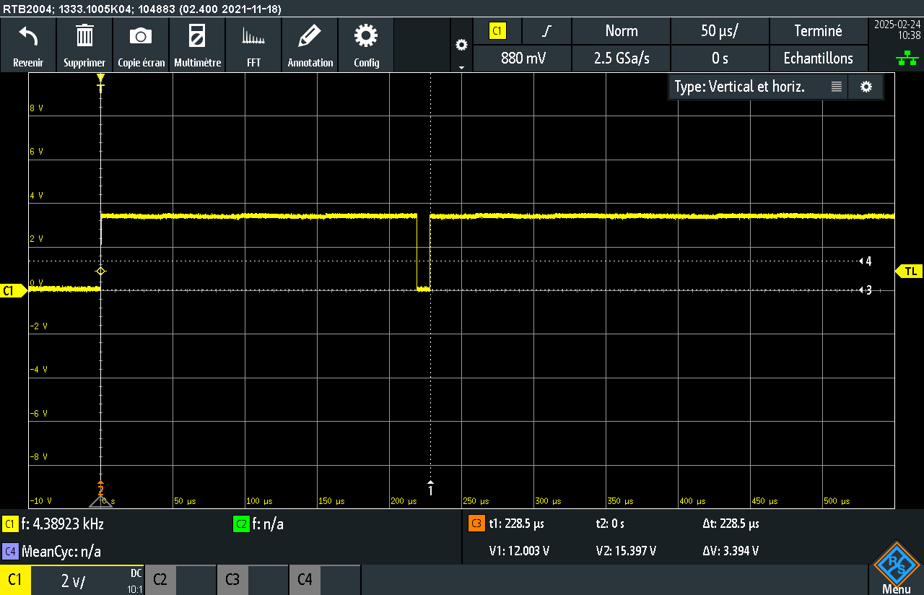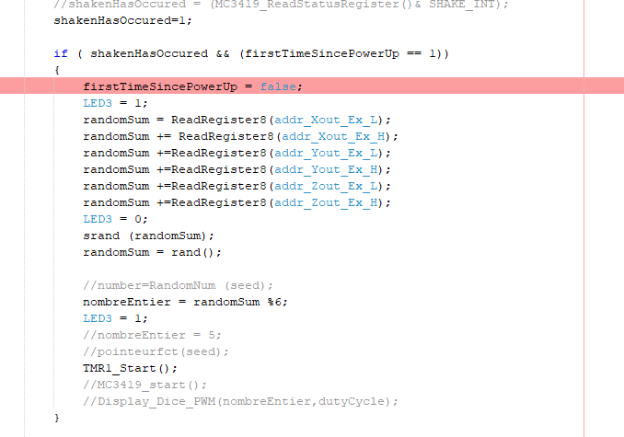
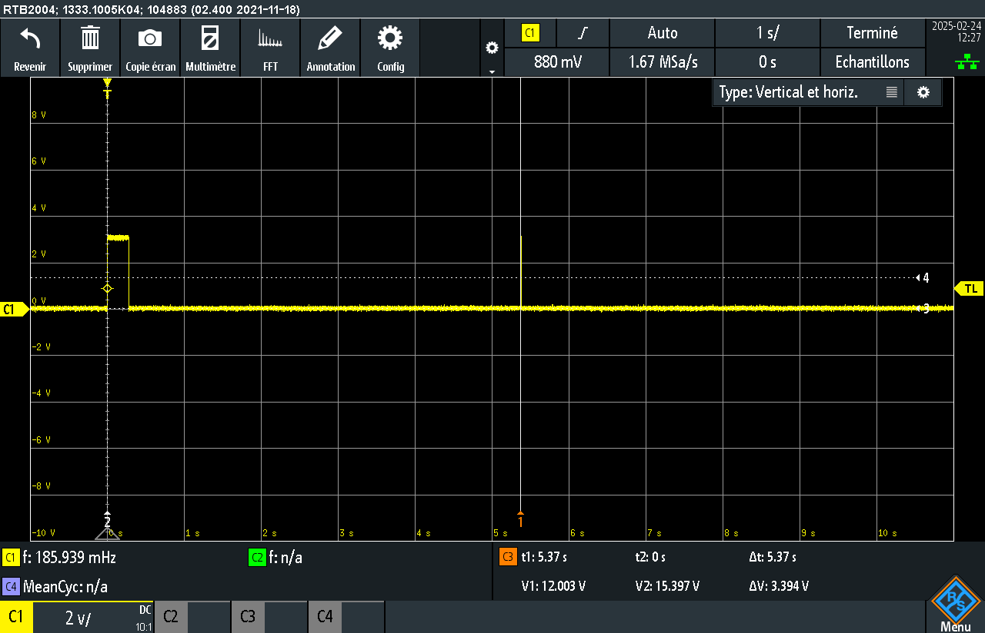
Lecture toute les registres : 150us
Attente interrupt :

SPI 4MHZ
Lecture reg status :~ 5S
SPI 4MHZ
INT_EXT: ~3S
SPI8MHZ:
Lecture reg status :~ 3S

